Synopsis

Traffic Accident Severity Prediction
Using Machine Learning

Problem Id: 20

Name - Antriksh Singh Jagwan
University Roll No. - 2028649
Section - Q

Name - Anshuman Solanki
University Roll No. - 2028647
Section - Q

Name - Anish Mandal
University Roll No. - 2028642
Section - Q

- Problem Description:
Traffic accidents are a major issue affecting road safety and public health. The severity of accidents depends on several factors such as vehicle speed, weather conditions, road type, and vehicle category. Predicting accident severity can help authorities and emergency services respond more efficiently and reduce damage and casualties.

This project aims to develop a machine learning system that predicts the severity of traffic accidents based on various input features. The system will use historical accident data and apply preprocessing techniques to clean the dataset and remove irrelevant records. Feature selection methods will be used to identify the most important factors affecting accident severity, such as speed and weather conditions.

Machine learning algorithms such as Logistic Regression and Support Vector Machine (SVM) will be used to build the prediction model. The SVM model will use different kernels such as Linear, Polynomial, and RBF to capture simple and complex patterns in the data. The performance of the model will be evaluated using metrics like confusion matrix and recall score to measure prediction accuracy.

- Steps of Implementation:
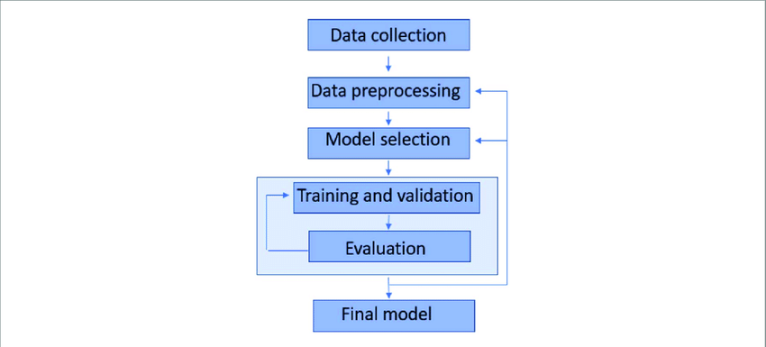
Fig. 1 Sample architecture

- Data Collection – Collect a traffic accident dataset containing features such as vehicle speed, weather conditions, road type, vehicle type, and other relevant factors affecting accident severity.
- Data Preprocessing – Clean the dataset by handling missing values, removing irrelevant records, and converting categorical data into numerical format suitable for machine learning.
- Feature Selection – Identify and select the most important features that significantly influence accident severity to improve model accuracy and efficiency.
- Model Training – Train machine learning models such as Logistic Regression and Support Vector Machine (SVM) using the processed dataset.
- Model Testing – Test the trained models using unseen test data to evaluate their ability to predict accident severity.
- Model Evaluation – Evaluate model performance using metrics such as confusion matrix, accuracy, recall, and F1-score. Visualization techniques like confusion matrix heatmap, correlation heatmap, ROC curve, and accuracy comparison charts will be used for analysis.

- Expected Modules/ Libraries to be used:
- NumPy – Used for numerical computations and array operations.
- Pandas – Used for data manipulation and handling datasets.
- Matplotlib – Used for visualizing data and plotting graphs.
- Scikit-learn – Used to implement machine learning algorithms like Logistic Regression and SVM.

- Expected Evaluation metrics and Plots to be used:
- Confusion Matrix:
A confusion matrix summarizes the prediction results by showing True Positives (TP), True Negatives (TN), False Positives (FP), and False Negatives (FN). It helps analyze how accurately the model classifies accident severity.
- Recall Score:
Recall measures the model’s ability to correctly identify actual severe accidents. A higher recall ensures that serious accidents are not missed by the system.
- Graphs for Analysis:
The following plots will be used to analyze model performance:
- Confusion Matrix Heatmap – to visualize prediction accuracy.
- Accuracy Comparison Bar Chart – to compare different models.
- Correlation Heatmap – to analyze relationships between dataset features.
- ROC Curve – to evaluate classification performance.

- Required topics from the subject:
- Strings – Used to process categorical data like weather conditions.
- Files – Used for reading datasets and saving results.

- Platform Required:
Jupyter Notebook

- Books and Link Sources:
- Hands-On Machine Learning with Scikit-Learn, Keras & TensorFlow – Aurélien Géron
- Pattern Recognition and Machine Learning – Christopher Bishop
- https://scikit-learn.org
- https://www.kaggle.com

